**REAL ESTATE MANAGEMENT SYSTEM**

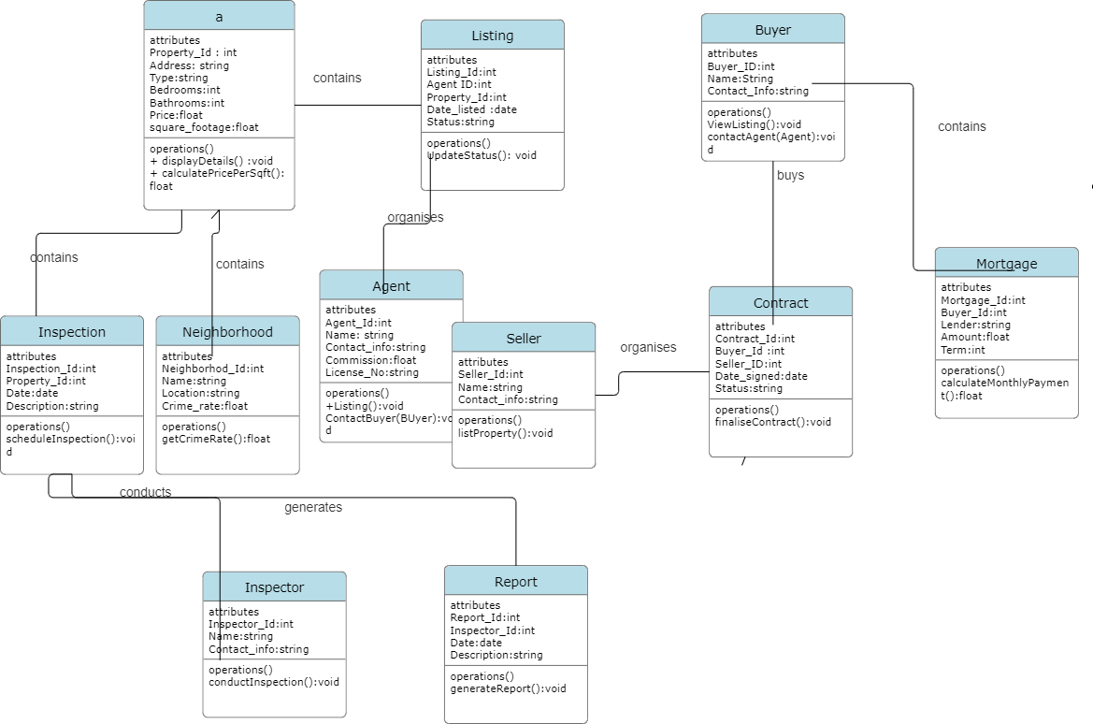

Problem Statement:

The real estate industry faces several challenges due to the complexity and volume of data that needs to be managed. Traditional methods of handling real estate transactions are often manual, inefficient, and prone to errors.

1. **Inefficient Data Management**: Handling numerous properties, agents, buyers, sellers, contracts, and inspections manually leads to data inconsistency and errors.
2. **Time-Consuming Processes**: Manual processes for creating listings, managing contracts, and processing mortgages are time-consuming and reduce productivity.
3. **Lack of Integration**: Different stakeholders use separate systems or methods to manage their part of the process, leading to fragmented information and miscommunication.
4. **Limited Accessibility**: Stakeholders often struggle to access up-to-date information quickly, which can delay decision-making and transactions.
5. **Poor Tracking and Reporting**: Difficulty in tracking the status of properties, listings, contracts, and inspections can lead to missed opportunities and compliance issues.

**Objectives of REMS**

1. **Centralize Data Management**: Provide a single platform to store and manage all real estate data, ensuring consistency and accuracy.
2. **Automate Processes**: Automate key processes such as property listings, contract management, and mortgage processing to improve efficiency and reduce manual errors.
3. **Enhance Communication**: Improve communication and information sharing among stakeholders by providing real-time access to data.
4. **Increase Accessibility**: Allow stakeholders to access and manage information from anywhere, anytime, through a web-based interface.
5. **Improve Tracking and Reporting**: Provide robust tracking and reporting tools to monitor the status of properties, listings, contracts, and inspections.

To specify the relationships among the entities using terms like "contains," "organizes," "buys," "can have," "contains," "works for," we can map the terms to the corresponding relationships in the class diagram.

**Relationship Descriptions**

1. **Property-Listing**:
   * **Contains**: A Property contains multiple Listings.
   * **Organizes**: A Listing is organized for a Property.
2. **Agent-Listing**:
   * **Works for**: A Listing works for an Agent.
   * **Organizes**: An Agent organizes multiple Listings.
3. **Buyer-Contract**:
   * **Buys**: A Buyer buys multiple Contracts.
   * **Organizes**: A Contract is organized for a Buyer.
4. **Seller-Contract**:
   * **Organizes**: A Seller organizes multiple Contracts.
   * **Can have**: A Contract can have one Seller.
5. **Buyer-Mortgage**:
   * **Can have**: A Buyer can have multiple Mortgages.
   * **Contains**: A Mortgage contains one Buyer.
6. **Property-Inspection**:
   * **Contains**: A Property contains multiple Inspections.
   * **Organizes**: An Inspection is organized for a Property.
7. **Neighborhood-Property**:
   * **Contains**: A Neighborhood contains multiple Properties.
   * **Belongs to**: A Property belongs to one Neighborhood.
8. **Inspector-Inspection**:
   * **Conducts**: An Inspector conducts multiple Inspections.
   * **Organizes**: An Inspection is organized by one Inspector.
9. **Inspector-Report**:
   * **Generates**: An Inspector generates multiple Reports.
   * **Organizes**: A Report is organized by one Inspector.

**ss**